- Do steps 1 through 10 in this doc: https://w.amazon.com/bin/view/AWSentralMCP/#HWindows
- Start a Windows WSL (the black penguin icon) window
- Open a PowerShell window
- In the PowerShell window
  - Run mwinit
- In the WSL window
  - Run this command, replacing the <username> with your AWS alias:
alias refresh-midway='cp /mnt/c/Users/<username>/.midway/cookie ~/.midway/cookie && echo "Midway cookie synced"'
  - Then run this command: refresh-midway
- Then in Quick Desktop
  - go to Settings → Capabilities → Connections → scroll to Advanced Integrations → click "+ Add MCP / Skill"
  - in the dialog box:
    - Name: aws-sentral-mcp
    - Command: wsl.exe
    - Arguments (replace <username> with your AWS alias):
bash -ic /home/<username>/.toolbox/bin/aws-sentral-mcp
for example:
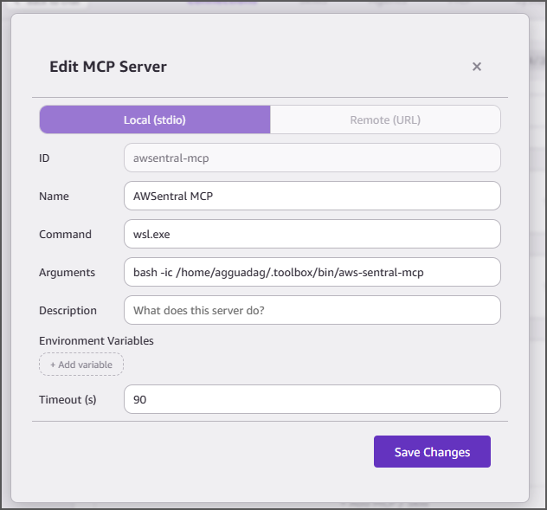
Remember: you will have to run mwinit in PowerShell and refresh-midway in WSL to authenticate every day before opening Quick desktop each day.

Steps to enable admin access: - From the Start menu, search for and open ACME - Click the Utilities tab - In the Administrative Access menu, click Enable Admin Access - ACME will produce a pop-up showing that you'll have administrator access for 4 hours - Click Dismiss to close the window and maintain administrator access

